1． Product Structure
1.1 Diagram For Vaginal Speculum
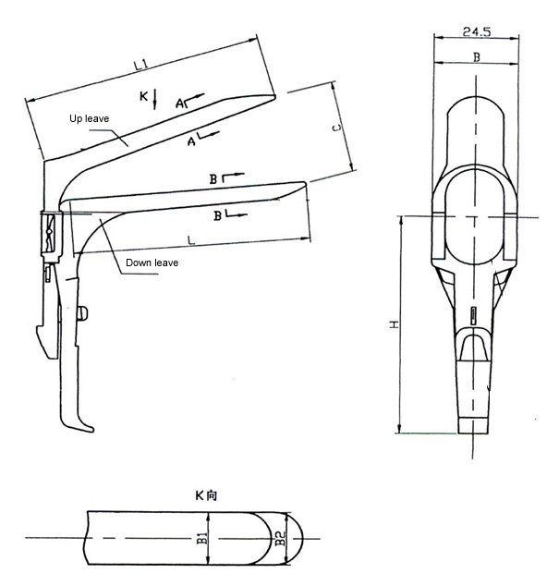
1.2 Specification and size for Vaginal Speculum

Specification & Type | Basic size (mm)
 | L | L1 | B | B1 | B2 | C | H
4913 Large | 141±2 | 140±2 | 34±1 | 32±1 | 32±1 | 62±2 | 127±2
4912 Middle | 108±2 | 107±2 | 34±1 | 31±1 | 30±1 | 64±2 | 127±2
4911 Small | 107±2 | 106±2 | 34±1 | 22±1 | 22±1 | 84±2 | 127±2

